

HARRY POTTER™: THE EXHIBITION
OPENS IN SALT LAKE CITY - MEMORIAL DAY WEEKEND
TICKETS ON SALE MARCH 20TH

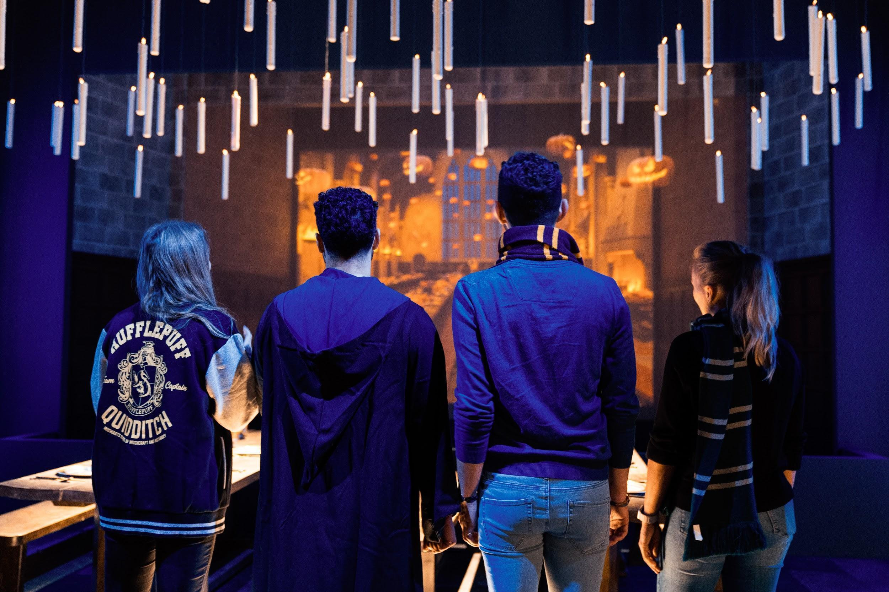

Salt Lake City, Utah (March 11, 2025) – Warner Bros. Discovery Global Experiences, Imagine, and Eventim Live are excited to announce that the U.S. tour of Harry Potter™: The Exhibition will make its next stop in Salt Lake City, debuting at the Shops at South Town on May 24. Prepare yourself for the most extensive touring exhibition ever created that celebrates the enchanting world of Harry Potter and beyond, which has already captivated over 3.3 million fans worldwide.
Tickets will go on sale March 20, 2025. Join the waitlist today to ensure your spellbinding experience with early access to tickets. For those who join the waitlist, a presale will be offered beginning March 17, 2025.
The behind-the-scenes exhibition celebrates the iconic moments, characters, settings, and beasts as seen from the films of Harry Potter and Fantastic Beasts™, as well as the wonders of the extended Harry Potter universe, including costumes, props and imagery from the Tony® award-winning Broadway production Harry Potter and the Cursed Child. Guests can experience the beautifully crafted environments that honor many of the unforgettable moments from the films and that fans and audiences have loved for more than two decades, getting an up-close look at everything from original costumes to authentic props as they embark on a personalized journey through innovative, awe-inspiring, and magical environments using best-in-class immersive design and technology.
As a dynamic city that combines adventure, a thriving arts and entertainment scene, and a strong sense of community, Salt Lake City is a perfect stop for Harry Potter: The Exhibition on its U.S. tour. “With a family-friendly environment and great appreciation for storytelling and adventure, this is an ideal destination to share the magic of Harry Potter with fans and families of all ages. We couldn’t be more excited to bring this beloved all-new exhibition to the Salt Lake City area this summer,” said Tom Zaller, President and CEO of Imagine.
Since its world premiere in Philadelphia in February 2022, Harry Potter: The Exhibition has captivated over 3.3 million fans and visitors worldwide. The exhibition has traveled to major cities around the globe and is currently on display in Boston, USA; Madrid, Spain; and Sao Paulo, Brazil.

Exhibition Gallery Highlights
From Page to Screen, the Gallery showcases a first edition of Harry Potter and the Sorcerer’s Stone encased in a Gringotts-inspired vault and is surrounded by inspirational video and literary quotes, reconnecting guests to the story as they are introduced to the exhibition.
Hogwarts Castle Gallery features an immersive multimedia experience with iconic elements like the Whomping Willow, Dementors, and the Marauder’s Map, where guests will see their name appear, prompting them to continue their exploration of the exhibition.
The Great Hall Gallery is a space that allows visitors to celebrate magical seasonal moments in its iconic architecture.
The Hogwarts Houses gallery sets the foundation for the exhibition experience, allowing guests the opportunity to experience more personalized moments with the Hogwarts house they select during their pre-registration. While guests may gravitate towards one house, this gallery will enable visitors to experience all of the Hogwarts houses in a celebratory hall featuring an iconic Sorting Hat, perfect for photo ops, while surrounded by freshly designed house crests on meticulously created stained glass windows.
Hogwarts Classrooms are filled with iconic props, creatures, and costumes. Visitors will interact with magical lessons and games through digital touchscreens to reveal behind-the-scenes secrets about iconic classroom moments. They will brew potions in the Potions Classroom, predict the future in Divination, pot a mandrake in the Herbology Greenhouse, and use their digital wand to defeat a boggart in Defense Against the Dark Arts.
Hagrid’s Hut and The Forbidden Forest offer an interactive Patronus charm experience. Guests will then uncover iconic creatures, such as centaurs and Acromantula, hidden in the forest and explore inside a recreation of Hagrid’s Hut.
An exclusive collection of Harry Potter: The Exhibition merchandise will be available in the onsite retail shop for guests to celebrate their fandom. Fans can choose from a range of products such as apparel, jewelry, and edible treats, including Chocolate Frogs and bottled and draft Butterbeer. There will also be merchandise not available at any other Harry Potter experience.
Fans are encouraged to follow Harry Potter: The Exhibition on Facebook and Instagram and shop the Exhibition’s online shop.
#HarryPotterExhibition

Ticket information
Adult tickets start at $25 plus tax and fees.
Child tickets start at $15 plus tax and fees.
Tickets are available for purchase here.

###

About the Harry Potter franchise
From the moment eleven-year-old Harry Potter met Rubeus Hagrid, Keeper of Keys and Grounds at Hogwarts School of Witchcraft and Wizardry, his adventures have left an indelible mark on popular culture. Today, over 25 years later, the Harry Potter phenomenon thrives as one of the most successful and best-loved entertainment properties in history.
J.K. Rowling’s best-selling Harry Potter novels have been brought to life in an ever-evolving, interconnected universe which is loved by millions of fans worldwide. Eight blockbuster Harry Potter films and three epic Fantastic Beasts films bring the spellbinding action to life on screen, Harry Potter and the Cursed Child mesmerises on stage, and state-of-the-art video and mobile games from Portkey Games allow players to experience the wizarding world like never before. Fans can proudly showcase their passion through innovative consumer products, and thrill at spectacular location-based experiences - including five theme park lands at Universal Studios locations around the world.
This expanding portfolio of Warner Bros. Discovery-owned Harry Potter and Fantastic Beasts offerings includes ground-breaking touring experiences and events, each developed to celebrate special moments and locations that fans cherish, as well as the Platform 9 3⁄4 retail shops and iconic flagship store - Harry Potter New York. Wizards, Witches and Muggles alike can also discover something new as they explore behind-the-scenes secrets at Warner Bros. Studio Tour London – The Making of Harry Potter and Warner Bros. Studio Tour Tokyo – The Making of Harry Potter.
With a new HBO Original TV series based on the Harry Potter books on the way, this extended world continues to provide the community with fresh and exciting ways to interact. For its global fans, and for generations to come, it invites everyone in to find the magic for themselves.
For the latest Harry Potter and Fantastic Beasts news and features, visit https://www.harrypotter.com/
All characters and elements © & ™ Warner Bros. Entertainment Inc. Publishing Rights © JKR. (s25)

About Warner Bros. Discovery Global Experiences
Warner Bros. Discovery Global Experiences (WBDGE) is a worldwide leader in the creation, development, licensing and operating of location-based entertainment based on the biggest franchises, stories, and characters from Warner Bros.’ world-renowned film, television, animation, and games studios, HBO, Discovery, Cartoon Network and more. WBDGE is home to the groundbreaking locations of The Wizarding World of Harry Potter at Universal theme parks around the world, award-winning Warner Bros. Studio Tour locations in London, Hollywood, and Tokyo, the iconic Harry Potter New York flagship store, Warner Bros. World Abu Dhabi, The WB Abu Dhabi, The FRIENDS Experience, The Game of Thrones Studio Tour and countless other experiences inspired by Harry Potter, DC, Looney Tunes, Scooby-Doo, Game of Thrones, FRIENDS and more. WBDGE is part of Warner Bros. Discovery’s Revenue & Strategy division.

About Imagine
Imagine (formerly known as Imagine Exhibitions) is a global leader in immersive storytelling and experiential design, specializing in the development of world-class exhibitions and attractions for museums, studios, IPs, brands, and leisure destinations worldwide. Through its four core services — Exhibitions, Studio, Retail, and Operations — Imagine creates visitor experiences that entertain, educate, and inspire.

Imagine’s Exhibitions division creates, tours, and operates award-winning traveling experiences like Harry Potter: The Exhibition and Downton Abbey: The Exhibition, captivating audiences and driving attendance worldwide. Its Studio plans, designs, and produces both traveling and permanent experiences, offering comprehensive creative services for clients seeking unique, story-driven experiences. The Retail division enhances guest engagement and drives revenue through bespoke product development, store design, and operations, while the Operations team provides extensive consulting, marketing, and operational support, ensuring the seamless and profitable management of visitor experiences across various venues.

Imagine is currently producing, presenting or operating more than 40 unique experiences around the globe, spanning museums, science centers, zoos, botanical gardens, integrated resorts, and non-traditional venues. For more information, visit www.theimagineteam.com or follow Imagine on Facebook, Instagram and Linkedin.

For general media inquiries:
Imagine
Joanna Wilbee-Amis
jwilbee-amis@theimagineteam.com
press@harrypotterexhibition.com
Lindsay Kiesel | Warner Bros. Discovery Global Experiences
Lindsay.Kiesel@wbd.com

For business-related inquiries, including hosting the exhibition:
sales@imagineexhibitions.com

