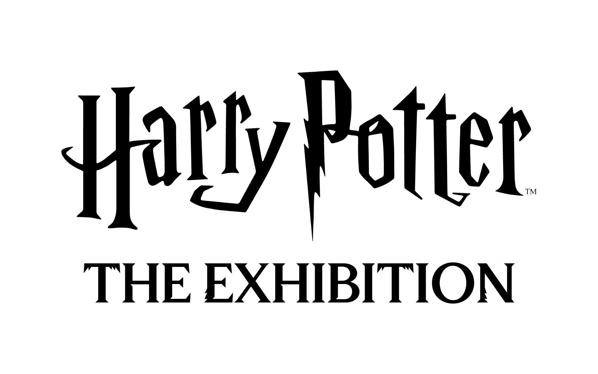

**"HARRY POTTER: THE EXHIBITION" ARRIVES IN MADRID ON OCTOBER 4**

**ESPACIO IBERCAJA DELICIAS**

**For A Limited Time**

**EXCLUSIVE TICKET PRE-SALE IS NOW ACTIVE ON THE WEBSITE.**

**GENERAL SALE FROM SEPTEMBER 2!**

**Madrid** (August 26, 2024) – Harry Potter: The Exhibition opens October 4 at Espacio Ibercaja Delicias in the heart of Madrid! Prepare yourself for the most comprehensive touring exhibition ever presented about the enchanting world of Harry Potter - which has mesmerized over 2 million fans worldwide since its opening. Tickets go on sale to the general public on Monday, September 2 at 10:00 a.m. at harrypotterexhibition.com, doctormusic.com and entradas.com. Exclusive pre-sale tickets for the exhibition are active now for fans who sign up for free at harrypotterexhibition.com.

**Tom Zaller**, President and CEO of **Imagine Exhibitions**, said: *“We’re delighted to bring this exhibition to Harry Potter fans in Madrid as well as visitors to the city and throughout all of Spain. This exhibition celebrates the behind-the-scenes filmmaking magic of Harry Potter like no other touring experience – if you're a lifelong Harry Potter fan or just discovering the magic, there's something for everyone in this exhibition.”*

**Neo Sala**, founder and CEO of **Doctor Music**, stated: *“After the great experience in Barcelona with the exhibition, we couldn't pass up the opportunity to bring it to Madrid. The Harry Potter universe is impressive and not only for fans, but the entire public can enjoy this interactive experience, it’s such a great way to celebrate the films. It is totally recommended for those who want to have fun with friends and family, a perfect plan for all audiences.”*

**Harry Potter™: The Exhibition** is a groundbreaking traveling exhibition that celebrates iconic moments, characters, settings and creatures from the **Harry Potter™** and **Fantastic Beasts™** films, as well as the extended Harry Potter universe. At the exhibition, visitors can practice their **Quidditch™** skills, brew a **potion**, pot a **mandrake**, earn points for your **Hogwarts™** house and more, all while learning behind-the-scenes filmmaking magic.

Guests can experience the beautifully crafted environments that honor many of the unforgettable moments fans and audiences have loved for more than two decades, getting an up-close look at everything from **original costumes** to **authentic props** as they embark on a **personalized journey** through innovative, awe-inspiring, and magical environments using best-in-class design and technology. As visitors explore each gallery, their interactions are captured using **RFID wristbands** to deliver **unique experiences** linked to their visitor profile.

An exclusive collection of Harry Potter: The Exhibition merchandise will be available in the onsite retail shop for guests to celebrate their fandom. Fans can choose from a range of products such as apparel, jewelry, and edible treats, including Chocolate Frogs and bottled and draft Butterbeer. There will also be merchandise not available at any other Harry Potter experience.

This exhibition was created and developed by Warner Bros. Discovery Global Themed Entertainment in partnership with Imagine Exhibitions and Eventim Live.

Fans are encouraged to follow [Harry Potter: The Exhibition](http://www.harrypotterexhibition.com/) on [Facebook,](https://www.facebook.com/Harry-Potter-The-Exhibition-104783201990750) [Instagram](https://www.instagram.com/harrypotter_exhibition/), and [Twitter](https://twitter.com/HP_Exhibition). #HarryPotterExhibition

###

**About the Harry Potter franchise**

From the moment eleven-year-old Harry Potter met Rubeus Hagrid, Keeper of Keys and Grounds at Hogwarts School of Witchcraft and Wizardry, his adventures have left an indelible mark on popular culture. Today, over 25 years later, the Harry Potter phenomenon thrives as one of the most successful and best-loved entertainment properties in history.

J.K. Rowling’s best-selling Harry Potter novels have been brought to life in an ever-evolving, interconnected universe which is loved by millions of fans worldwide. Eight blockbuster *Harry Potter* films and three epic *Fantastic Beasts* films bring the spellbinding action to life on screen, *Harry Potter and the Cursed Child* mesmerises on stage, and state-of-the-art video and mobile games from Portkey Games allow players to experience the wizarding world like never before. Fans can proudly showcase their passion through innovative consumer products, and thrill at spectacular location-based experiences - including five theme park lands at Universal Studios locations around the world.

This expanding portfolio of Warner Bros. Discovery-owned Harry Potter and Fantastic Beasts offerings includes ground-breaking touring experiences and events, each developed to celebrate special moments and locations that fans cherish, as well as the Platform 9 3⁄4 retail shops and iconic flagship store - Harry Potter New York. Wizards, Witches and Muggles alike can also discover something new as they explore behind-the-scenes secrets at *Warner Bros. Studio Tour London – The Making of Harry Potter* and *Warner Bros. Studio Tour Tokyo – The Making of Harry Potter*.

With a new HBO Original TV series based on the Harry Potter books on the way, this extended world continues to provide the community with fresh and exciting ways to interact. For its global fans, and for generations to come, it invites everyone in to find the magic for themselves.

For the latest Harry Potter and Fantastic Beasts news and features, visit [www.wizardingworld.com](http://www.wizardingworld.com).

*All characters and elements © & ™ Warner Bros. Entertainment Inc. Publishing Rights © JKR. (s24)*

**About Warner Bros. Discovery Global Themed Entertainment**

Warner Bros. Discovery Global Themed Entertainment (WBDGTE), part of Warner Bros. Discovery’s Revenue & Strategy division, is a worldwide leader in the creation, development, and licensing of location-based entertainment, live events, exhibits, and theme park experiences based on Warner Bros.’ iconic characters, stories, and brands. WBDGTE is home to the groundbreaking global locations of The Wizarding World of Harry Potter™, Warner Bros. World Abu Dhabi, WB Movie World Australia, and countless other experiences inspired by DC, Looney Tunes, Scooby, Game of Thrones, Friends, and more. With best-in-class partners, WBDGTE allows fans worldwide to physically immerse themselves inside their favourite brands and franchises.

**About Imagine Exhibitions**

Atlanta-based Imagine Exhibitions, Inc. is a world leader in narrative-driven, immersive theatrical design, story-telling, and immersive experiences, and creates sophisticated, high-quality experiences for museums, brands, venues, and integrated resorts across the globe. From ideation to operation, Imagines’ team of industry pioneers draws upon decades of success in the fields of immersive design experiences and entertainment to consistently create and implement memorable and thought-provoking environments. The company’s custom experiences deliver focused messaging and serve to increase attendance wherever it is presented. Imagine Exhibitions, Inc. is a global pioneer in traveling entertainment, responsible for many internationally recognized exhibitions such as *Harry Potter: The Exhibition, Titanic: The Exhibition, The Hunger Games: The Exhibition, Angry Birds: The Art & Science Behind a Global Phenomenon, Jurassic World: The Exhibition,* and *Downton Abbey: The Exhibition.*

Imagine Exhibitions is currently presenting more than 40 unique exhibitions in museums, science centers, aquariums, integrated resorts, and non-traditional venues worldwide. The company also continues to design, open, and operate its own venues, along with creating and implementing permanent and semi-permanent museum, brand, entertainment properties, and food and beverage experiences. For more information, visit www.ImagineExhibitions.com or find us on Facebook.

**About Eventim Live**

EVENTIM LIVE is the promoter group of CTS EVENTIM. With a network of 39 promoters worldwide, EVENTIM LIVE is uniquely positioned to offer a wide range of live entertainment experiences tailored to diverse audiences. From large-scale global tours to intimate local concerts and iconic festivals, Eventim Live ensures that fans have access to the most exciting events across various genres and locations. EVENTIM LIVE also excels in the dynamic realm of touring exhibitions, contributing to the cultural exchange that defines this growing segment.

**About Doctor Music:**

Doctor Music is a concert promoter and music events company based in Spain, with offices in Madrid and Barcelona. Leading company in the live music industry for more than 42 years. Doctor Music was one of the first companies to organize a massive music festival in Spain, creating the Doctor Music Festival in Escalarre in 1996. It has worked with artists such as Bruce Springsteen, U2, The Rolling Stones, Paul McCartney, Leonard Cohen, Adele, Bon Jovi, R.E.M., Red Hot Chili Peppers, Radiohead, Tina Turner, David Bowie, Lou Reed, Depeche Mode, Mark Knopfler, Dire Straits, Prince, Pink Floyd, Santana, Whitney Houston, The Black Keys, Bruno Mars, Miley Cyrus, Justin Bieber, Shawn Mendes, Lorde, or Måneskin, among many others. More information at doctormusic.com.

**For General Media Inquiries:**

**DOCTOR MUSIC (MARKETING & COMMS)**

Silvia Ortega |+34 93 268 28 28 | sortega@doctormusic.com

Ana López |+34 93 268 28 28 | alopez@doctormusic.com

**FOCUS (PRESS & PR)**

Sandra Fernández Isardo | +34 646 929 699 | sfernandez@focus.es

Paula Ramos | + 34 695 087 310 | pramos@focus.es

Pablo García |+34 644 159 428 | pgarcia@focus.es

**Imagine Exhibitions**

[**press@harrypotterexhibition.com**](mailto:press@harrypotterexhibition.com)

**Lindsay Kiesel | Warner Bros. Discovery Global Themed Entertainment**

[**Lindsay.Kiesel@wbd.com**](mailto:Lindsay.Kiesel@wbd.com)

**For business-related inquiries, including hosting the exhibition:**[**sales@imagineexhibitions.com**](mailto:sales@imagineexhibitions.com)