

**HARRY POTTER: THE EXHIBITION IS**

**NOW OPEN IN MADRID**

**GET YOUR** [**TICKETS**](http://harrypotterexhibition.com/) **NOW!**

*Espacio Ibercaja Delicias – Madrid*

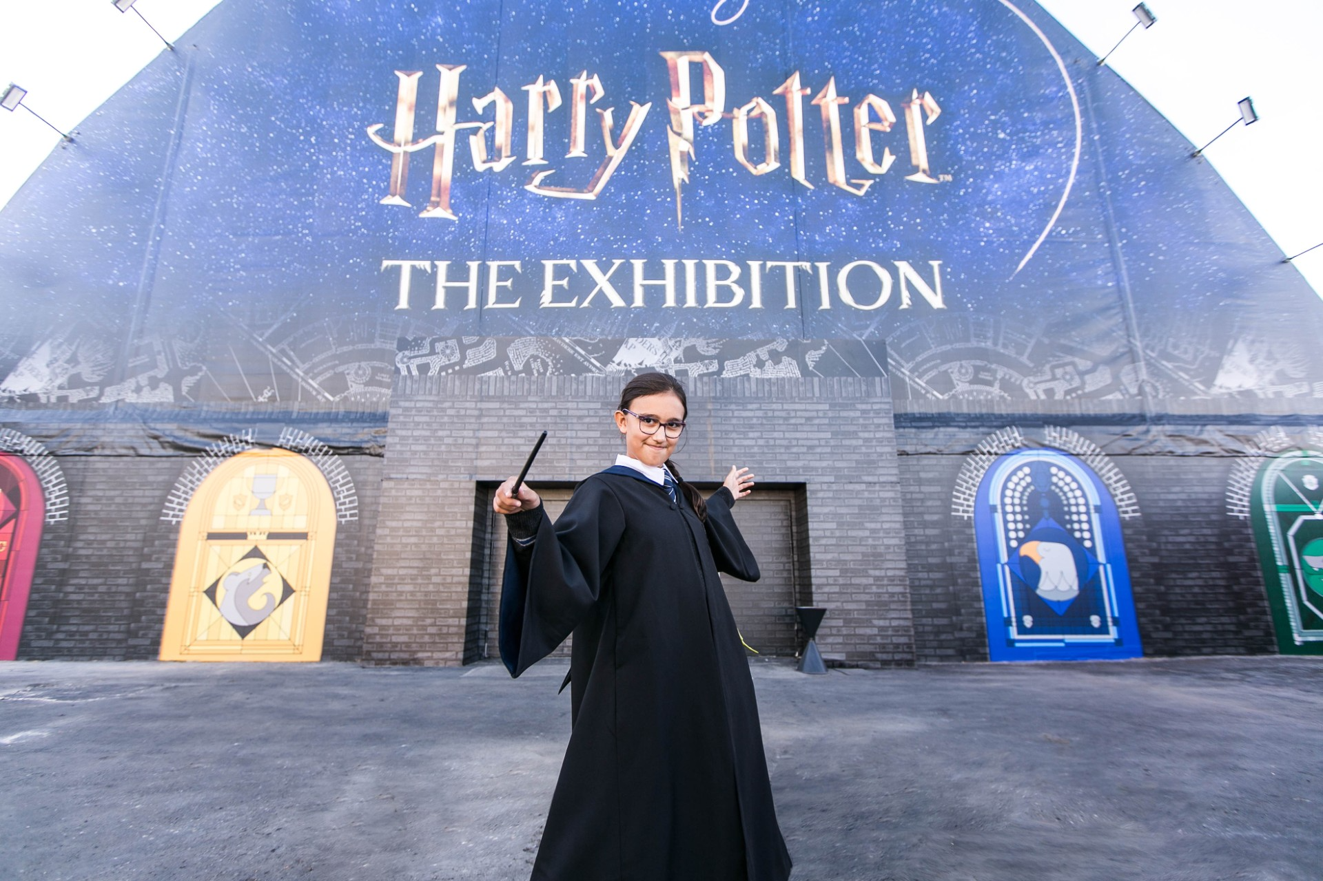

*Visitors line up for the opening day at Harry Potter: The Exhibition at Espacio Ibercaja Delicias in Madrid.*

**Madrid, Spain (October 4, 2024).** Madrid is a little more magical this week as *Harry Potter: The Exhibition*—the behind-the-scenes, interactive, and most comprehensive touring exhibition ever presented on Harry Potter’s universe—welcomes its first visitors at Espacio Ibercaja Delicias.

Espacio Ibercaja Delicias is a new space, centrally located and easily accessible by bus, suburban train and metro (Delicias, line 3). A place accessible to all that makes it the perfect place to explore this enchanting exhibition.

The exhibition, which will be in town until January 6, delights visitors through an exciting behind-the-scenes journey to explore iconic moments, characters, sets and creatures from the *Harry Potter* and *Fantastic Beasts* films, as well as the Tony® Award-winning Broadway production of *Harry Potter and the Cursed Child*. The exhibition is open every day of the week to visitors of all ages and tickets are available at harrypotterexhibition.com, doctormusic.com and tickets.com.

***Harry Potter: The Exhibition*** takes visitors of all ages on a one-of-a-kind journey through the extended world of Harry Potter, celebrating some of the most iconic moments from the beloved *Harry Potter* and *Fantastic Beasts films*. Upon entry, everyone is given an exhibition wristband for a personalized experience. From selecting a Hogwarts house (either Gryffindor, Hufflepuff, Ravenclaw, or Slytherin) to picking your wand and Patronus, visitors will be able to create their own, uniquely magical moments while earning points for their house with each interactive activity.

Throughout the exhibition, visitors will experience everything from the hall of moving portraits to the famed scene of the Great Hall with floating candles to exploring Hogwarts classrooms, filled with authentic props and costumes. Hagrid’s Hut and oversized chair is perfect for photo opps, as is the “cupboard under the stairs” from Harry’s childhood. In addition, vignettes from *Fantastic Beasts* and costumes from the Tony® award-winning Broadway production *Harry Potter and The Cursed Child* are included in the exhibition, making Harry Potter: The Exhibition the most comprehensive touring exhibition ever presented about the extended world of Harry Potter, perfect for both longtime fans and those just starting to experience the magic.

Tom Zaller, CEO of Imagine Exhibitions, said, “We have something very special here in Madrid, and I am excited for the people of Spain to get the chance to experience this show. Visitors will be able to see original props and costumes from some of their favorite scenes from the films, have their photos taken and earn points through interactive games in the various rooms. I encourage everyone to buy their tickets in advance for this experience as it’s something you won’t want to miss!”

Following the world premiere in Philadelphia, USA in February 2022, **Harry Potter: The Exhibition** has since welcomed over 2.5 million guests in several cities around the world. Currently, it’s also showing in Macao, China, Boston, USA and São Paulo, Brazil.

**Exhibition Highlights**

**From Page to Screen Gallery** showcases a first edition of *Harry Potter and the Sorcerer’s Stone* encased in a Gringotts inspired vault and is surrounded by inspirational video and literary quotes, reconnecting guests to the story as they are introduced to the exhibition.

**Hogwarts Castle Gallery** features a multimedia experience with iconic elements such as the Womping Willow, Dementors and the Marauder's Map, where guests will see their name appear, prompting them to continue their exploration of the exhibition.

**The Hogwarts Houses** gallery sets the foundation for the exhibition experience, allowing guests the opportunity to experience more personalized moments with the Hogwarts house they select during their entry. While guests may gravitate towards one house, this gallery will enable visitors to experience all the Hogwarts houses in a celebratory hall featuring an iconic Sorting Hat, perfect for photo ops, while surrounded by freshly designed house crests on meticulously created stained glass windows.

**Hogwarts Classrooms** are filled with iconic props, creatures, and costumes. Visitors will interact with magical lessons and games through digital touchscreens to reveal behind-the-scenes secrets about iconic classroom moments. They will brew potions in the Potions Classroom, predict the future in Divination, repot a mandrake in the Herbology Greenhouse, and use their digital wand to defeat a boggart in Defense Against the Dark Arts.

**Hagrid’s Hut and The Forbidden Forest** offer an interactive Patronus charm experience. Guests will then uncover mysterious creatures, such as centaurs and Acromantula, hidden in the forest and explore inside of Hagrid’s Hut.

An exclusive collection of *Harry Potter: The Exhibition* merchandise will be available in the on-site store for visitors to celebrate their fandom. Fans will be able to choose from a wide range of merchandise, including apparel, jewelry and treats such as chocolate frogs and bottled butterbeer and butterbeer on tap. There will also be items that will not be available at any other Harry Potter experience.

This exhibition has been created and developed by Warner Bros. Discovery Global Experiences in partnership with Imagine Exhibitions and Eventim Live.

We encourage fans to follow [Harry Potter: The Exhibition](https://harrypotterexhibition.com/) on [Facebook](https://www.facebook.com/HarryPotterExhibition), [Instagram](https://www.instagram.com/harrypotter_exhibition/) and [X](https://twitter.com/HP_Exhibition). #HarryPotterExhibition

**Ticket information**

Harry Potter: The Exhibition will be open daily in Madrid from October 4, 2024 until January 6, 2025. With prices starting at 14 euros, the interactive experience is a unique attraction for visitors of any age. Tickets can be purchased at [harrypotterexhibition.com](http://www.harrypotterexhibition.com/), [doctormusic.com](http://www.doctormusic.com/) and [entradas.com](http://www.entradas.com/)

VIP tickets are a popular giveaway. The VIP ticket allows access any day and time, commemorative lanyard, fast-track entry, tote bag, exclusive poster and free audio guide.

For more information on tickets, schedules and frequently asked questions, visit <https://harrypotterexhibition.com/es/locations/madrid>/.

**###**

**About Harry Potter**

From the moment eleven-year-old Harry Potter met Rubeus Hagrid, Keeper of Keys and Grounds at Hogwarts School of Witchcraft and Wizardry, his adventures have left an indelible mark on popular culture. Today, over 25 years later, the Harry Potter phenomenon thrives as one of the most successful and best-loved entertainment properties in history.

J.K. Rowling’s best-selling Harry Potter novels have been brought to life in an ever-evolving, interconnected universe which is loved by millions of fans worldwide. Eight blockbuster *Harry Potter* films and three epic *Fantastic Beasts* films bring the spellbinding action to life on screen, *Harry Potter and the Cursed Child* mesmerises on stage, and state-of-the-art video and mobile games from Portkey Games allow players to experience the wizarding world like never before. Fans can proudly showcase their passion through innovative consumer products, and thrill at spectacular location-based experiences - including five theme park lands at Universal Studios locations around the world.

This expanding portfolio of Warner Bros. Discovery-owned Harry Potter and Fantastic Beasts offerings includes ground-breaking touring experiences and events, each developed to celebrate special moments and locations that fans cherish, as well as the Platform 9 3⁄4 retail shops and iconic flagship store - Harry Potter New York. Wizards, Witches and Muggles alike can also discover something new as they explore behind-the-scenes secrets at *Warner Bros. Studio Tour London – The Making of Harry Potter* and *Warner Bros. Studio Tour Tokyo – The Making of Harry Potter*.

With a new HBO Original TV series based on the Harry Potter books on the way, this extended world continues to provide the community with fresh and exciting ways to interact. For its global fans, and for generations to come, it invites everyone in to find the magic for themselves.

For the latest Harry Potter and Fantastic Beasts news and features, visit [www.wizardingworld.com](http://www.wizardingworld.com).

*All characters and elements © & ™ Warner Bros. Entertainment Inc. Publishing Rights © JKR. (s24)*

**About Warner Bros. Discovery Global Experiences**

Warner Bros. Discovery Global Experiences (WBDGE), part of Warner Bros. Discovery’s Revenue & Strategy division, is a worldwide leader in the creation, development, and licensing of location-based entertainment, live events, exhibits, and theme park experiences based on Warner Bros.’ iconic characters, stories, and brands. WBDGE is home to the groundbreaking global locations of The Wizarding World of Harry Potter™, Warner Bros. World Abu Dhabi, WB Movie World Australia, and countless other experiences inspired by DC, Looney Tunes, Scooby, Game of Thrones, Friends, and more. With best-in-class partners, WBDGE allows fans worldwide to physically immerse themselves inside their favourite brands and franchises.

**About Imagine Exhibitions**

Atlanta-based Imagine Exhibitions, Inc. is a world leader in narrative-driven, immersive theatrical design, story-telling, and immersive experiences, and creates sophisticated, high-quality experiences for museums, brands, venues, and integrated resorts across the globe. From ideation to operation, Imagines’ team of industry pioneers draws upon decades of success in the fields of immersive design experiences and entertainment to consistently create and implement memorable and thought-provoking environments. The company’s custom experiences deliver focused messaging and serve to increase attendance wherever it is presented. Imagine Exhibitions, Inc. is a global pioneer in traveling entertainment, responsible for many internationally recognized exhibitions such as *Harry Potter: The Exhibition, Titanic: The Exhibition, The Hunger Games: The Exhibition, Angry Birds: The Art & Science Behind a Global Phenomenon, Jurassic World: The Exhibition,* and *Downton Abbey: The Exhibition.*

Imagine Exhibitions is currently presenting more than 40 unique exhibitions in museums, science centers, aquariums, integrated resorts, and non-traditional venues worldwide. The company also continues to design, open, and operate its own venues, along with creating and implementing permanent and semi-permanent museum, brand, entertainment properties, and food and beverage experiences.

For more information, visit  [www.imagineexhibitions.com/](https://www.imagineexhibitions.com/) or find us on [Facebook](https://www.facebook.com/ImagineExhibitions/).

**About Eventim Live**

EVENTIM LIVE is the promoter group of CTS EVENTIM. With a network of 39 promoters worldwide, EVENTIM LIVE is uniquely positioned to offer a wide range of live entertainment experiences tailored to diverse audiences. From large-scale global tours to intimate local concerts and iconic festivals, Eventim Live ensures that fans have access to the most exciting events across various genres and locations. EVENTIM LIVE also excels in the dynamic realm of touring exhibitions, contributing to the cultural exchange that defines this growing segment.

**About Doctor Music:**

Doctor Music is a concert promoter and music events company based in Spain, with offices in Madrid and Barcelona. Leading company in the live music industry for more than 42 years. Doctor Music was one of the first companies to organize a massive music festival in Spain, creating the Doctor Music Festival in Escalarre in 1996. It has worked with artists such as Bruce Springsteen, U2, The Rolling Stones, Paul McCartney, Leonard Cohen, Adele, Bon Jovi, R.E.M., Red Hot Chili Peppers, Radiohead, Tina Turner, David Bowie, Lou Reed, Depeche Mode, Mark Knopfler, Dire Straits, Prince, Pink Floyd, Santana, Whitney Houston, The Black Keys, Bruno Mars, Miley Cyrus, Justin Bieber, Shawn Mendes, Lorde, or Måneskin, among many others. More information at doctormusic.com.

**About Espacio Ibercaja Delicias**

In the heart of Madrid, Espacio Ibercaja Delicias is a different place, where shows, art and fun come together to offer unique experiences. Since its opening in 2021, this space has become a reference in the city of Madrid, where 2 million visitors have already passed through. With a multipurpose and multi-purpose approach, Espacio Ibercaja Delicias is designed to host a wide variety of activities, events and shows. In just three years, Espacio Ibercaja Delicias has brought new dynamism and life to the Arganzuela district and has become an essential meeting point for those looking for quality entertainment in Madrid.

[**PRESS MATERIALS AVAILABLE HERE**](https://www.dropbox.com/scl/fo/d1bkrkhoyrq0kbui1mizp/AO0ARlET7pu_qnexvI00YQA?rlkey=2laxna8n1ors1vi7wrseu5vlg&st=fr9ij8sr&dl=0)

**For press inquiries:**

**DOCTOR MUSIC (MARKETING & COMMS)**

Silvia Ortega |+34 93 268 28 28 | sortega@doctormusic.com

Ana López |+34 93 268 28 28 28 | alopez@doctormusic.com

**FOCUS (PRESS & PR)**

Sandra Fernández Isardo | +34 646 929 699 | sfernandez@focus.es

Paula Ramos | + 34 695 087 310 | pramos@focus.es

**Imagine Exhibitions**

press@harrypotterexhibition.com

**Lindsay Kiesel | Warner Bros. Discovery Global Experiences**

Lindsay.Kiesel@wbd.com

**For company-related inquiries, including exhibition organization:**

sales@imagineexhibitions.com