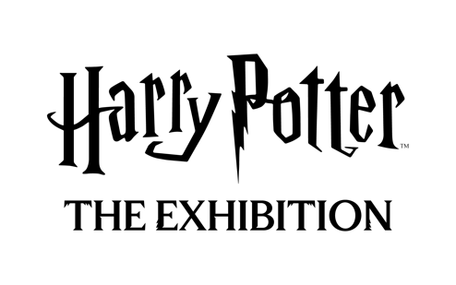

HARRY POTTER™: THE EXHIBITION IS COMING TO MELBOURNE!

The groundbreaking, interactive touring exhibition will celebrate
its Australia Premiere in Melbourne this autumn!
Tickets go on sale March 5, 2025

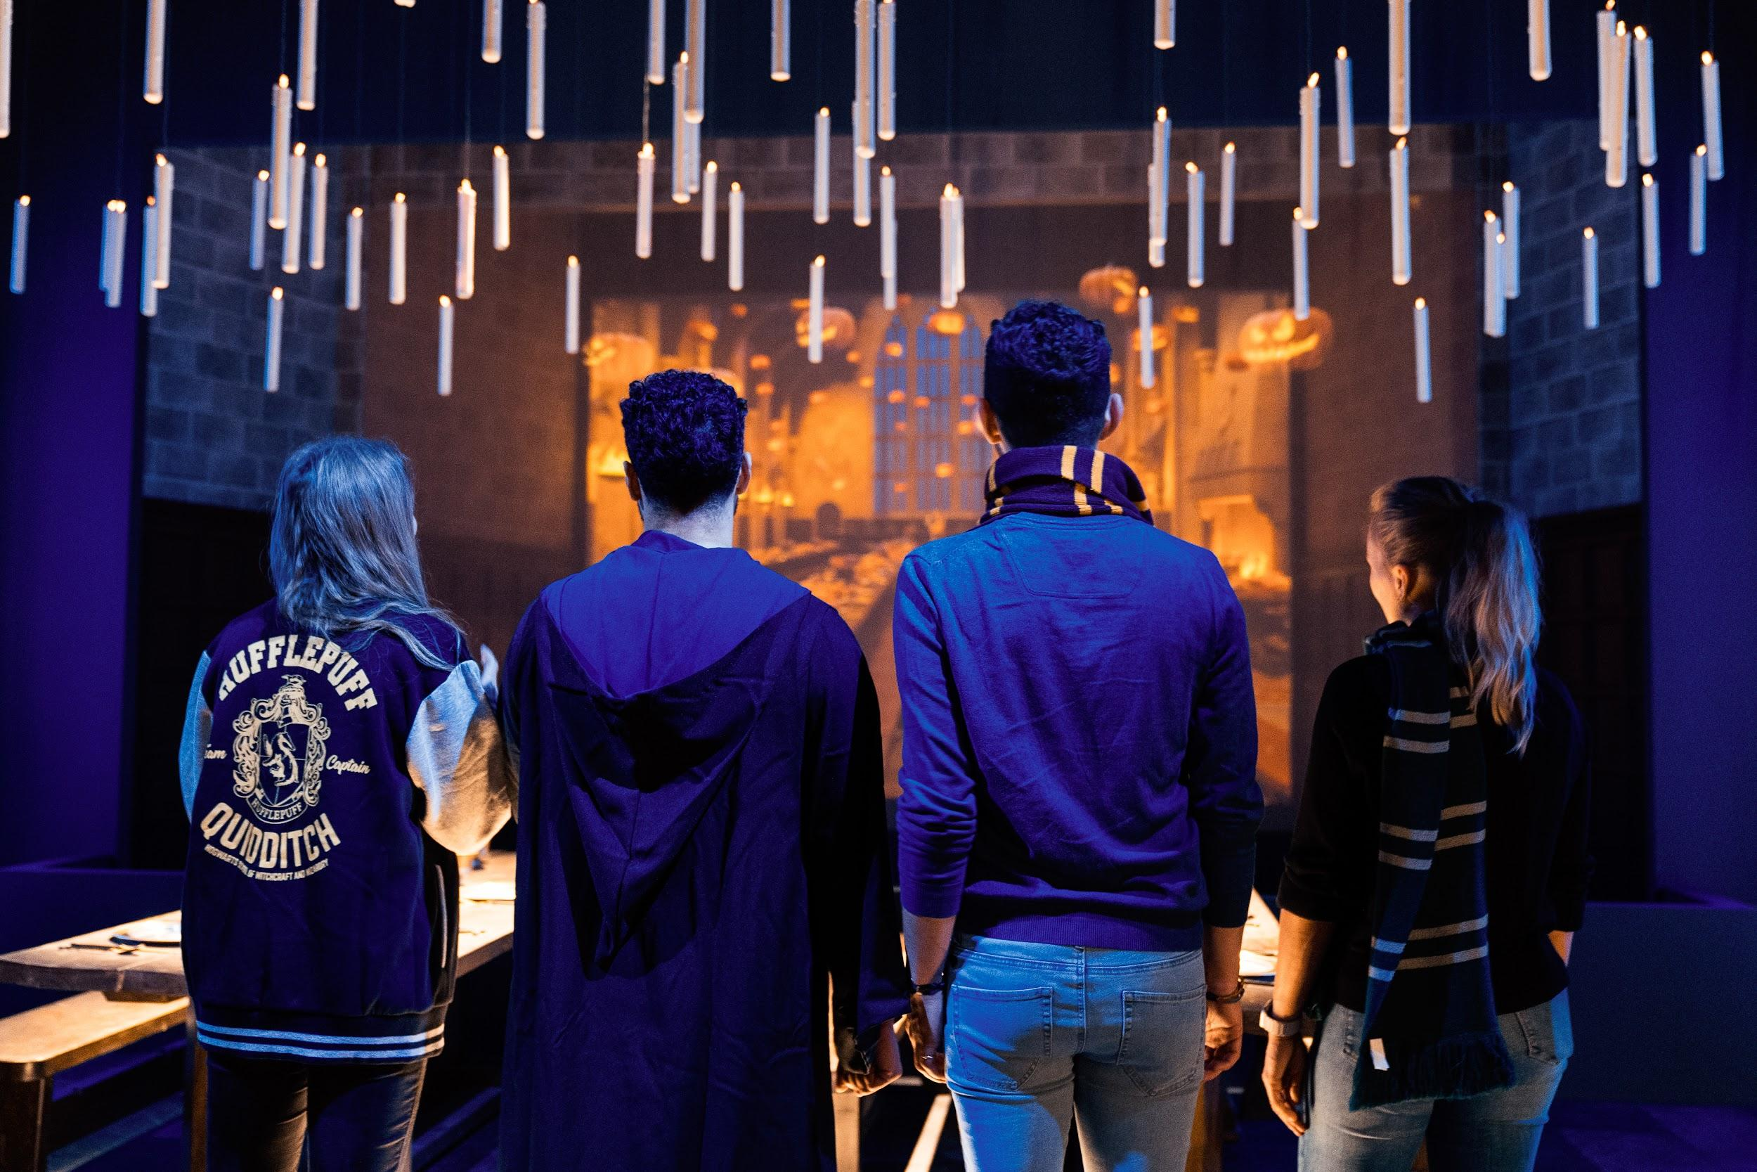

MELBOURNE | February 25, 2025 - Warner Bros. Discovery Global Experiences, Imagine Exhibitions, and Eventim Live have announced that Harry Potter: The Exhibition is making its Australia premiere in Melbourne this coming April at the Fever Exhibition and Experience Centre. The waitlist for tickets is now live at harrypotterexhibition.com.

The behind-the-scenes exhibition celebrates the iconic moments, characters, settings, and beasts as seen from the films of Harry Potter and Fantastic Beasts™, as well as the wonders of the extended Harry Potter universe, including costumes, props and imagery from the Tony® award-winning Broadway production Harry Potter and the Cursed Child. Guests can experience the beautifully crafted environments that honour many of the unforgettable moments from the films and that fans and audiences have loved for more than two decades, getting an up-close look at everything from original costumes to authentic props as they embark on a personalised journey through innovative, awe-inspiring, and magical environments using best-in-class immersive design and technology.

Following the world premiere in Philadelphia, USA in February 2022, Harry Potter: The Exhibition has since opened in several cities around the world and welcomed over 3.3 million visitors and fans of Harry Potter. It is currently showing in Boston, USA and Madrid, Spain.

"This exhibition celebrates the extended world of Harry Potter like no other touring exhibition has done before,” said Tom Zaller, President and CEO of Imagine Exhibitions. “I have wanted to open in Australia since we began planning and I am so happy to finally launch the waitlist in Melbourne. We can't wait to share it with visitors, fans and families from all over the country when we open this autumn!"

Throughout the exhibition, visitors will experience everything from the hall of moving portraits to
the famed scene of the Great Hall with floating candles, to exploring Hogwarts classrooms,
filled with authentic props and costumes. Hagrid’s Hut and oversized chair is perfect for photo
opps, as is the “cupboard under the stairs” from Harry’s childhood. In addition, vignettes from
Fantastic Beasts and costumes from the Tony® award-winning Broadway production Harry
Potter and The Cursed Child are included in the exhibition, making Harry Potter: The Exhibition
the most in-depth touring exhibition looking at the entire Harry Potter universe, perfect for both
longtime fans and those just starting to experience the magic.

Gallery Highlights
From Page to Screen Gallery showcases a first edition of Harry Potter and the Philosopher’s Stone encased in a Gringotts-inspired vault and is surrounded by inspirational video and literary quotes, reconnecting guests to the story as they are introduced to the exhibition.
Hogwarts Castle Gallery features an immersive multimedia experience with iconic elements like the Whomping Willow, Dementors, and the Marauder’s Map, where guests will see their name appear, prompting them to continue their exploration of the exhibition.
The Great Hall Gallery is a space that allows visitors to celebrate magical seasonal moments in its iconic architecture.
The Hogwarts Houses gallery sets the foundation for the exhibition experience, allowing guests the opportunity to experience more personalised moments with the Hogwarts house they select during their pre-registration. While guests may gravitate towards one house, this gallery will enable visitors to experience all the Hogwarts houses in a celebratory hall featuring the iconic Sorting Hat, perfect for photo ops, while surrounded by freshly designed house crests on meticulously created stained glass windows.
Hogwarts Classrooms are filled with iconic props, creatures, and costumes. Visitors will interact with magical lessons and games through digital touchscreens to reveal behind-the-scenes secrets about iconic classroom moments. They will brew potions in the Potions Classroom, predict the future in Divination, pot a mandrake in the Herbology Greenhouse, and use their digital wand to defeat a boggart in Defense Against the Dark Arts.
Hagrid’s Hut and The Forbidden Forest offers an interactive Patronus charm experience. Guests will then uncover iconic creatures, such as centaurs and Acromantula, hidden in the forest and explore inside a recreation of Hagrid’s Hut.
An exclusive collection of Harry Potter: The Exhibition merchandise will be available in the onsite retail shop for guests to celebrate their fandom. Fans can choose from a range of products such as apparel, jewellery, and edible treats, including Chocolate Frogs and bottled and draft Butterbeer. There will also be merchandise not available at any other Harry Potter experience.
Fans are encouraged to follow Harry Potter: The Exhibition on Facebook and Instagram. #harrypotterexhibition @harrypotter_exhibition
###

About The Harry Potter Franchise
From the moment eleven-year-old Harry Potter met Rubeus Hagrid, Keeper of Keys and Grounds at Hogwarts School of Witchcraft and Wizardry, his adventures have left an indelible mark on popular culture. Today, over 25 years later, the Harry Potter phenomenon thrives as one of the most successful and best-loved entertainment properties in history.

J.K. Rowling’s best-selling Harry Potter novels have been brought to life in an ever-evolving, interconnected universe which is loved by millions of fans worldwide. Eight blockbuster Harry Potter films and three epic Fantastic Beasts films bring the spellbinding action to life on screen, Harry Potter and the Cursed Child mesmerises on stage, and state-of-the-art video and mobile games from Portkey Games allow players to experience the wizarding world like never before. Fans can proudly showcase their passion through innovative consumer products, and thrill at spectacular location-based experiences - including five theme park lands at Universal Studios locations around the world.

This expanding portfolio of Warner Bros. Discovery-owned Harry Potter and Fantastic Beasts offerings includes ground-breaking touring experiences and events, each developed to celebrate special moments and locations that fans cherish, as well as the Platform 9 3⁄4 retail shops and iconic flagship store - Harry Potter New York. Wizards, Witches and Muggles alike can also discover something new as they explore behind-the-scenes secrets at Warner Bros. Studio Tour London – The Making of Harry Potter and Warner Bros. Studio Tour Tokyo – The Making of Harry Potter.

With a new HBO Original TV series based on the Harry Potter books on the way, this extended world continues to provide the community with fresh and exciting ways to interact. For its global fans, and for generations to come, it invites everyone in to find the magic for themselves.

For the latest Harry Potter and Fantastic Beasts news and features, visit www.harrypotter.com.

All characters and elements © & ™ Warner Bros. Entertainment Inc. Publishing Rights © JKR. (s25)

About Warner Bros. Discovery Global Experiences
Warner Bros. Discovery Global Experiences (WBDGE) is a worldwide leader in the creation, development, licensing and operating of location-based entertainment based on the biggest franchises, stories, and characters from Warner Bros.’ world-renowned film, television, animation, and games studios, HBO, Discovery, Cartoon Network and more. WBDGE is home to the groundbreaking locations of The Wizarding World of Harry Potter at Universal theme parks around the world, award-winning Warner Bros. Studio Tour locations in London, Hollywood, and Tokyo, the iconic Harry Potter New York flagship store, Warner Bros. World Abu Dhabi, The WB Abu Dhabi, The FRIENDS Experience, The Game of Thrones Studio Tour and countless other experiences inspired by Harry Potter, DC, Looney Tunes, Scooby-Doo, Game of Thrones, FRIENDS and more. WBDGE is part of Warner Bros. Discovery’s Revenue & Strategy division.

About Imagine Exhibitions
Atlanta-based Imagine Exhibitions, Inc. is a world leader in narrative-driven, immersive theatrical design, story-telling, and immersive experiences, and creates sophisticated, high-quality experiences for museums, brands, venues, and integrated resorts across the globe. From ideation to operation, Imagines’ team of industry pioneers draws upon decades of success in the fields of immersive design experiences and entertainment to consistently create and implement memorable and thought-provoking environments. The company’s custom experiences deliver focused messaging and serve to increase attendance wherever it is presented. Imagine Exhibitions, Inc. is a global pioneer in traveling entertainment, responsible for many internationally recognized exhibitions such as Harry Potter: The Exhibition, Titanic: The Exhibition, The Hunger Games: The Exhibition, Angry Birds: The Art & Science Behind a Global Phenomenon, Jurassic World: The Exhibition, and Downton Abbey: The Exhibition.

Imagine Exhibitions is currently presenting more than 40 unique exhibitions in museums, science centers, aquariums, integrated resorts, and non-traditional venues worldwide. The company also continues to design, open, and operate its own venues, along with creating and implementing permanent and semi-permanent museum, brand, entertainment properties, and food and beverage experiences. For more information, visit www.ImagineExhibitions.com or find us on Facebook.

About Eventim Live
EVENTIM LIVE is the promoter group of CTS EVENTIM. With a network of 39 promoters worldwide, EVENTIM LIVE is uniquely positioned to offer a wide range of live entertainment experiences tailored to diverse audiences. From large-scale global tours to intimate local concerts and iconic festivals, Eventim Live ensures that fans have access to the most exciting events across various genres and locations. EVENTIM LIVE also excels in the dynamic realm of touring exhibitions, contributing to the cultural exchange that defines this growing segment.

For Media Inquiries

For Media Inquiries about Harry Potter: The Exhibition in Melbourne
IMAGINE EXHIBITIONS
press@harrypotterexhibition.com

WARNER BROS. DISCOVERY
Lindsay Kiesel | Warner Bros. Discovery Global Experiences
lindsay.Kiesel@wbd.com

For business-related inquiries, including hosting the exhibition:
sales@imagineexhibitions.com

