

HARRY POTTER ™ : Die Ausstellung
kommt nach Dresden

Vorverkaufsstart am 03. Dezember 2025, 10 Uhr

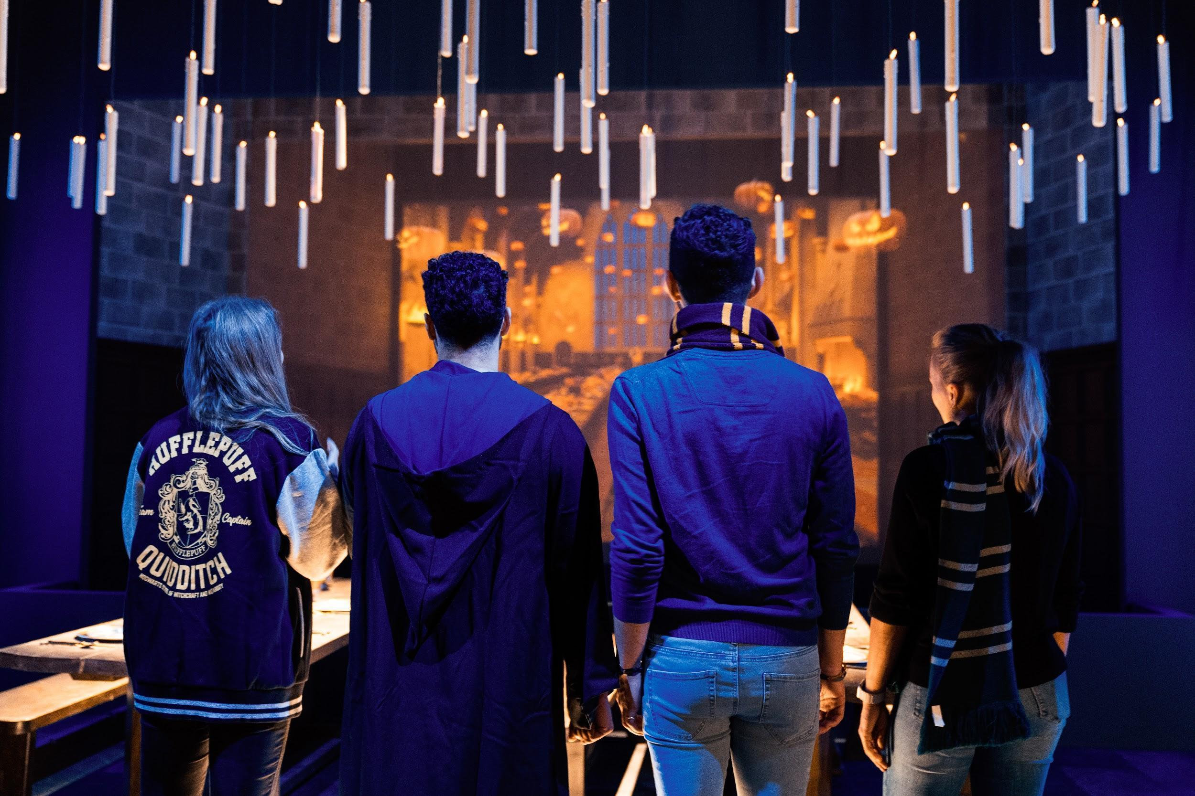

Dresden, 02.12.2025 – Warner Bros. Discovery Global Experiences, Imagine und Eventim Live freuen sich bekannt zu geben, das die weltweite Tournee von „Harry Potter: Die Ausstellung“ ab dem 19. Dezember 2025 im Erlewein Forum in Dresden zu sehen sein wird. Freuen Sie sich auf die umfangreichste Wanderausstellung, die jemals geschaffen wurde, um die zauberhafte Welt von Harry Potter und darüber hinaus zu feiern. Über 4 Millionen Fans hat die Ausstellung bereits weltweit in ihren Bann gezogen.

Tickets für „Harry Potter: Die Ausstellung“ in Dresden, sind ab Mittwoch, den 03.
Dezember 2025, 10 Uhr auf eventim.de und ab Freitag, den 05. Dezember 2025, 10
Uhr an allen bekannten Vorverkaufsstellen erhältlich.

Die Ausstellung wirft einen Blick hinter die Kulissen und präsentiert die ikonischen
Momente, Charaktere, Schauplätze und Tierwesen aus den Filmen und Geschichten von„Harry Potter™“ und „Fantastische Tierwesen™“. Ebenso werden die Wunder der
erweiterten Welt inklusive der Kostüme, Requisiten und Bilder aus der Tony®-gekrönten
Broadway-Produktion „Harry Potter und das verwunschene Kind“ gezeigt. Die Besucher
können in wunderschön gestalteten Kulissen, die seit mehr als zwei Jahrzehnten von Fans und Publikum geliebt werden, unvergessliche Momente erleben. Von Originalkostümen hin zu authentischen Requisiten können sie alles aus nächster Nähe betrachten. Während Ihrer persönlichen Reise durch innovative, beeindruckende und magische Umgebungen, die mithilfe von erstklassigem immersiven Design und Technologie geschaffen wurden, erleben sie die Atmosphäre hautnah.

„Diese Ausstellung würdigt die erweiterte Welt von Harry Potter auf eine Weise, wie es
keine Wanderausstellung zuvor getan hat“, erklärt Tom Zaller, Präsident und CEO von
Imagine. „Mit ihrer familienfreundlichen Atmosphäre und ihrer tiefen Wertschätzung für
Storytelling und Abenteuer ist Dresden der ideale Ort, an dem Fans und Familien jeden
Alters die Magie der Zaubererwelt entdecken können. Wir freuen uns außerordentlich
darauf, dieses Erlebnis noch im Dezember in Dresden zu eröffnen und mit Besucherinnen und Besuchern aus nah und fern zu teilen.“

Highlights der Galerien:

„Von der Seite zur Leinwand”-Galerie: In einem von Gringotts inspirierten Tresorraum
ist eine Erstausgabe von Harry Potter und der Stein der Weisen ausgestellt. Umgeben von inspirierenden Videos und wörtlichen Zitaten werden beim Eintreten die Erinnerungen der Besucher an die Geschichten und Filme von Harry Potter geweckt und diese mit der Ausstellung verbunden.

„Hogwarts-Schloss“-Galerie: Ein immersives Multimedia-Erlebnis mit ikonischen
Elementen erwartet die Fans in dieser Galerie mit der „Peitschenden Weide“, Dementoren und der Karte des Plünderers, auf der die Besucher selbst erscheinen und sie dazu ermuntert werden, die Ausstellung weiter zu erkunden.

„Große Halle“-Galerie: Die Große Halle mit ihrer ikonischen Architektur ermöglicht es
den Besuchern, magische saisonale Momente zu erleben und zelebrieren, wie sie es aus den Geschichten und Filmen kennen.

The Hogwarts Houses gallery sets the foundation for the exhibition experience, allowing guests the opportunity to experience more personalized moments with the Hogwarts house they select during their pre-registration. While guests may gravitate towards one house, this gallery will enable visitors to experience all the Hogwarts houses in a celebratory hall featuring the iconic Sorting Hat, perfect for photo ops, while surrounded by freshly designed house crests on meticulously created stained glass windows.
Hogwarts Classrooms are filled with iconic props, creatures, and costumes. Visitors will interact with magical lessons and games through digital touchscreens to reveal behind-the-scenes secrets about iconic classroom moments. They will brew potions in the Potions Classroom, predict the future in Divination, pot a mandrake in the Herbology Greenhouse, and use their digital wand to defeat a boggart in Defense Against the Dark Arts.
Hagrid’s Hut and The Forbidden Forest offer an interactive Patronus charm experience. Guests will then uncover iconic creatures, such as centaurs and Acromantula, hidden in the forest and explore inside a recreation of Hagrid’s Hut.
An exclusive collection of Harry Potter: The Exhibition merchandise will be available in the onsite retail shop for guests to celebrate their fandom. Fans can choose from a range of products such as apparel, jewelry, and edible treats, including Chocolate Frogs and bottled and draft Butterbeer. There will also be merchandise not available at any other Harry Potter experience.
Fans are encouraged to follow Harry Potter: The Exhibition on Facebook and Instagram. #harrypotterexhibition @harrypotter_exhibition.
###

About The Harry Potter Franchise
From the moment eleven-year-old Harry Potter met Rubeus Hagrid, Keeper of Keys and Grounds at Hogwarts School of Witchcraft and Wizardry, his adventures have left an indelible mark on popular culture. Today, over 25 years later, the Harry Potter phenomenon thrives as one of the most successful and best-loved entertainment properties in history.

J.K. Rowling’s best-selling Harry Potter novels have been brought to life in an ever-evolving, interconnected universe which is loved by millions of fans worldwide. Eight blockbuster Harry Potter films and three epic Fantastic Beasts films bring the spellbinding action to life on screen, Harry Potter and the Cursed Child mesmerizes on stage, and state-of-the-art video and mobile games from Portkey Games allow players to experience the wizarding world like never before. Fans can proudly showcase their passion through innovative consumer products, and thrill at spectacular location-based experiences - including themed lands at six Universal Destinations and Experiences theme parks around the world.

This expanding portfolio of Warner Bros. Discovery-owned Harry Potter and Fantastic Beasts offerings includes ground-breaking touring experiences and events, each developed to celebrate special moments and locations that fans cherish, as well as Harry Potter Shops in King’s Cross, New York, Chicago, Akasaka, and Harajuku. Wizards, witches and Muggles alike can also discover something new as they explore behind-the-scenes secrets at Warner Bros. Studio Tour London – The Making of Harry Potter and Warner Bros. Studio Tour Tokyo – The Making of Harry Potter.

With a new HBO Original TV series based on the Harry Potter books on the way, this extended world continues to provide the community with fresh and exciting ways to interact. For its global fans, and for generations to come, it invites everyone in to find the magic for themselves.

For the latest Harry Potter and Fantastic Beasts news and features, visit www.harrypotter.com.

All characters and elements © & ™ Warner Bros. Entertainment Inc. Publishing Rights © JKR. (s25)

About Warner Bros. Discovery Global Experiences
Warner Bros. Discovery Global Experiences (WBDGE) is a worldwide leader in the creation, development, licensing and operating of location-based entertainment based on the biggest franchises, stories, and characters from Warner Bros.’ world-renowned film, television, animation, and games studios, HBO, Discovery, Cartoon Network and more. WBDGE is home to the groundbreaking locations of The Wizarding World of Harry Potter at Universal theme parks around the world, award-winning Warner Bros. Studio Tour locations in London, Hollywood, and Tokyo, the iconic Harry Potter New York flagship store, Warner Bros. World Abu Dhabi, The WB Abu Dhabi, The FRIENDS Experience, The Game of Thrones Studio Tour and countless other experiences inspired by Harry Potter, DC, Looney Tunes, Scooby-Doo, Game of Thrones, FRIENDS and more. WBDGE is part of Warner Bros. Discovery’s Revenue & Strategy division.

About Imagine
Imagine (formerly known as Imagine Exhibitions) is a global leader in immersive storytelling and
experiential design, specializing in the development of world-class exhibitions and attractions
for museums, studios, IPs, brands, and leisure destinations worldwide. Through its four core
services — Exhibitions, Studio, Retail, and Operations — Imagine creates visitor experiences that entertain, educate, and inspire.

Imagine’s Exhibition division develops, manages, and tours award-winning traveling experiences with highlights including Harry Potter: The Exhibition, Jurassic World: The Exhibition, Titanic: The Exhibition, Downton Abbey: The Exhibition, and Hunger Games: The Exhibition, captivating audiences and driving attendance worldwide. Its Studio plans, designs, and produces both traveling and permanent experiences, offering comprehensive creative services for clients seeking unique, story-driven experiences. The Retail division enhances guest engagement and drives revenue through bespoke product development, store design, and operations, while the Operations team provides extensive consulting, marketing, and operational support, ensuring the seamless and profitable management of visitor experiences across various venues.

Imagine is currently producing, presenting or operating more than 40 unique experiences
around the globe, spanning museums, science centers, zoos, botanical gardens, integrated
resorts, and non-traditional venues. For more information, visit www.theimagineteam.com or
follow Imagine on Facebook, Instagram, and Linkedin.

About Eventim Live
EVENTIM LIVE is the promoter group of CTS EVENTIM. With a network of 39 promoters worldwide, EVENTIM LIVE is uniquely positioned to offer a wide range of live entertainment experiences tailored to diverse audiences. From large-scale global tours to intimate local concerts and iconic festivals, Eventim Live ensures that fans have access to the most exciting events across various genres and locations. EVENTIM LIVE also excels in the dynamic realm of touring exhibitions, contributing to the cultural exchange that defines this growing segment.

Semmel Concerts / Semmel Exhibition:
About Semmel Concerts
Semmel Concerts Entertainment GmbH is one of the leading promoters in Europe and has been among the top 10 promoters worldwide in the official POLLSTAR ranking for years. Alongside the business division Semmel Concerts, Semmel Exhibitions and Semmel Artists & Events complete the company structure. Semmel Exhibitions produces experiences that travel to venues around the world and present exhibitions at their own venues in Germany, Austria and the German-speaking part of Switzerland. The current portfolio of Semmel Exhibitions includes the productions Tutankhamun: His Tomb and His Treasures, MARVEL: Universe of Super Heroes, Spider-Man: Beyond Amazing – The Exhibition and most recently Disney100: The Exhibition, which together have thrilled more than nine million people worldwide and form a strong international network of museums, science centers, cultural sites and the creative industry. More information at www.semmel.de.
About COFO ENTERTAINMENT, Passau
With over half a century of expertise in the live entertainment sector, COFO Entertainment has established itself as one of the leading promoters in the German-speaking region. Since 2013, the company has expanded its portfolio to include high-caliber touring exhibitions. Among these are exhibitions such as Tutankhamun – His Tomb and His Treasures or Body Worlds as well as immersive exhibitions such as Van Gogh – The Immersive Experience or Titanic: An Immersive Journey. A particular success are the exhibitions produced by company head Oliver Forster about the street-art superstar The Mystery of Banksy – A Genius Mind and House of Banksy – An Unauthorized Exhibition.
In total, COFO has realized around 80 exhibition projects in Germany and abroad and has fascinated millions of visitors. The company stands for innovation, diversity and quality in the live entertainment and exhibition sector, always with the aim of creating unique and unforgettable experiences. More information at www.cofo.de.
For press inquiries regarding Harry Potter: The Exhibition in Dresden
Semmel Concerts Entertainment GmbH
Karolina Kiefer
Head of Media Relations
Office: +49 621 33935712
Mobile: +49 178 2099138
Kiefer.karolina@semmel.de
For Media Inquiries about Harry Potter: The Exhibition

IMAGINE
Joanna Wilbee-Amis
jwilbee-amis@theimagineteam.com
press@harrypotterexhibition.com

WARNER BROS. DISCOVERY
Lindsay Kiesel | Warner Bros. Discovery Global Experiences
lindsay.Kiesel@wbd.com

For business-related inquiries, including hosting the exhibition:
sales@imagineexhibitions.com

