
HARRY POTTER™: THE EXHIBITION IS COMING TO PRAGUE

TICKET SALES START TODAY AT 10:00

An Enchanting Exhibition Celebrating the world of Harry Potter
Opens at PVA EXPO Prague Letňany on 6 August

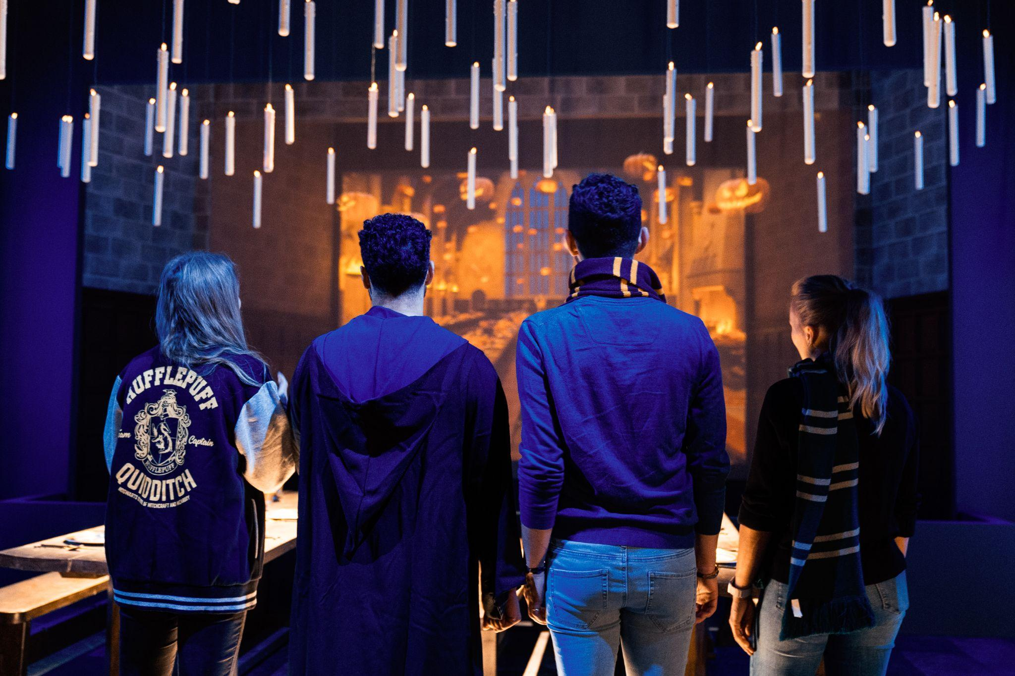

Prague, Czech Republic (4 May 2026) – Warner Bros. Discovery Global Experiences, Imagine, and Eventim Live are excited to announce that the global tour of Harry Potter™: The Exhibition will make its next stop in Prague, debuting at PVA EXPO Prague Letňany on 6 August. Prepare yourself for the most extensive touring exhibition ever created that celebrates the enchanting world of Harry Potter and beyond, which has already captivated over 4 million fans worldwide.

Tickets go on sale 4 May 2026 at 10:00 at www.harrypotterexhibition.com.

The behind-the-scenes exhibition celebrates the iconic moments, characters, settings, and creatures as seen in the Harry Potter and Fantastic Beasts™ film series, as well as wonders from the extended world of Harry Potter which includes the Tony® award-winning Broadway production Harry Potter and the Cursed Child. Guests can explore beautifully crafted environments that honor many of the unforgettable moments from the films that fans and audiences have loved over the past 25 years, getting an up-close look at everything from authentic props to original costumes as they journey through innovative, awe-inspiring, and magical galleries using best-in-class immersive design and interactive technology.
“This exhibition celebrates the unique world of Harry Potter and its films in a way no other touring exhibition has offered before,” said Tom Zaller, President and CEO of Imagine. “With its family-friendly environment and emphasis on storytelling and adventure, Prague is an ideal location where fans of all ages and their families can experience the behind-the-scenes of the films and more. We can’t wait to present it this August to guests from near and far.”
Exhibition Gallery Highlights:
As guests begin their visit, they encounter a first edition of Harry Potter and the Philosopher’s Stone, encased in a Gringotts-inspired vault. In the theater, Page to Screen moments featuring inspirational video and literary quotes reconnect them to the story. The Marauder’s Map also comes to life through a dynamic multimedia presentation that allows guests' names to appear on the map, and Hogwarts Castle vignettes highlight iconic elements such as the Whomping Willow and Dementors.
Hogwarts Castle Gallery features an immersive multimedia experience with iconic elements like the Whomping Willow, Dementors, and the Marauder’s Map, where guests will see their name appear, prompting them to continue their exploration of the exhibition.
The Great Hall Gallery is a space that allows visitors to celebrate magical seasonal moments in its iconic architecture.
The Hogwarts Houses gallery sets the foundation for the exhibition experience, allowing guests the opportunity to experience more personalized moments with the Hogwarts house they select during their preregistration. While guests may gravitate towards one house, this gallery will enable visitors to experience all of the Hogwarts houses in a celebratory hall featuring an iconic Sorting Hat, perfect for photo ops, while surrounded by freshly designed house crests on meticulously created stained glass windows.
Hogwarts Classrooms are filled with iconic props, creatures, and costumes. Visitors will interact with magical lessons and games through digital touchscreens to reveal behind-the-scenes secrets about iconic classroom moments. They will try their hand at brewing potions in the Potions Classroom, discover how to predict the future in Divination, pot a mandrake in the Herbology Greenhouse, and use their digital wand to defeat a Boggart in Defense Against the Dark Arts.
Hagrid’s Hut and The Forbidden Forest offer an interactive Patronus Charm experience. Guests will then uncover iconic creatures, such as centaurs and Acromantula, hidden in the forest and explore inside a recreation of Hagrid’s Hut.
An exclusive collection of Harry Potter: The Exhibition merchandise will be available in the onsite retail shop for guests to celebrate their fandom through an assortment of themed collections. Fans can choose from a range of products such as apparel, jewelry, and edible treats, including fan-favorite Chocolate Frogs and bottled Butterbeer, available while supplies last.Many items are bespoke to the exhibition and not available at any other Harry Potter experience.
Fans are encouraged to follow Harry Potter: The Exhibition on Facebook, and Instagram #HarryPotterExhibition @harrypotter_exhibition.
# # #

About The Harry Potter Franchise
From the moment eleven-year-old Harry Potter met Rubeus Hagrid, Keeper of Keys and Grounds at Hogwarts School of Witchcraft and Wizardry, his adventures have left an indelible mark on popular culture. Today, over 25 years later, the Harry Potter phenomenon thrives as one of the most successful and best-loved entertainment properties in history.

J.K. Rowling’s best-selling Harry Potter novels have been brought to life in an ever-evolving, interconnected universe which is loved by millions of fans worldwide. Eight blockbuster Harry Potter films and three epic Fantastic Beasts films bring the spellbinding action to life on screen, Harry Potter and the Cursed Child mesmerizes on stage, and state-of-the-art video and mobile games from Portkey Games allow players to experience the wizarding world like never before. Fans can proudly showcase their passion through innovative consumer products, and thrill at spectacular location-based experiences - including themed lands at six Universal Destinations and Experiences theme parks around the world.

This expanding portfolio of Warner Bros. Discovery-owned Harry Potter and Fantastic Beasts offerings includes ground-breaking touring experiences and events, each developed to celebrate special moments and locations that fans cherish, as well as Harry Potter Shops in King’s Cross, New York, Chicago, Akasaka, and Harajuku. Wizards, witches and Muggles alike can also discover something new as they explore behind-the-scenes secrets at Warner Bros. Studio Tour London – The Making of Harry Potter and Warner Bros. Studio Tour Tokyo – The Making of Harry Potter.

With a new HBO Original TV series based on the Harry Potter books on the way, this extended world continues to provide the community with fresh and exciting ways to interact. For its global fans, and for generations to come, it invites everyone in to find the magic for themselves.

For the latest Harry Potter and Fantastic Beasts news and features, visit www.harrypotter.com.

All characters and elements © & ™ Warner Bros. Entertainment Inc. Publishing Rights © JKR. (s26)

About Warner Bros. Discovery Global Experiences
Warner Bros. Discovery Global Experiences (WBDGE) is a worldwide leader in the creation, development, licensing and operating of location-based entertainment based on the biggest franchises, stories, and characters from Warner Bros.’ world-renowned film, television, animation, and games studios, HBO, Discovery, Cartoon Network and more. WBDGE is home to the groundbreaking locations of The Wizarding World of Harry Potter at Universal theme parks around the world, award-winning Warner Bros. Studio Tour locations in London, Hollywood, and Tokyo, the iconic Harry Potter New York flagship store, Warner Bros. World Abu Dhabi, The WB Abu Dhabi, The FRIENDS Experience, The Game of Thrones Studio Tour and countless other experiences inspired by Harry Potter, DC, Looney Tunes, Scooby-Doo, Game of Thrones, FRIENDS and more. WBDGE is part of Warner Bros. Discovery’s Revenue & Strategy division.

About Imagine
Imagine (formerly known as Imagine Exhibitions) is a global leader in immersive storytelling and
experiential design, specializing in the development of world-class exhibitions and attractions
for museums, studios, IPs, brands, and leisure destinations worldwide. Through its four core
services — Exhibitions, Studio, Retail, and Operations — Imagine creates visitor experiences that entertain, educate, and inspire.

Imagine’s Exhibition division develops, manages, and tours award-winning traveling experiences with highlights including Harry Potter: The Exhibition, Jurassic World: The Exhibition, Titanic: The Exhibition, Downton Abbey: The Exhibition, and Hunger Games: The Exhibition, captivating audiences and driving attendance worldwide. Its Studio plans, designs, and produces both traveling and permanent experiences, offering comprehensive creative services for clients seeking unique, story-driven experiences. The Retail division enhances guest engagement and drives revenue through bespoke product development, store design, and operations, while the Operations team provides extensive consulting, marketing, and operational support, ensuring the seamless and profitable management of visitor experiences across various venues.

Imagine is currently producing, presenting or operating more than 40 unique experiences
around the globe, spanning museums, science centers, zoos, botanical gardens, integrated
resorts, and non-traditional venues. For more information, visit www.theimagineteam.com or
follow Imagine on Facebook, Instagram, and Linkedin.

About Eventim Live
EVENTIM LIVE is the promoter group of CTS EVENTIM. With a network of 39 promoters worldwide, EVENTIM LIVE is uniquely positioned to offer a wide range of live entertainment experiences tailored to diverse audiences. From large-scale global tours to intimate local concerts and iconic festivals, Eventim Live ensures that fans have access to the most exciting events across various genres and locations. EVENTIM LIVE also excels in the dynamic realm of touring exhibitions, contributing to the cultural exchange that defines this growing segment.

For Media Inquiries about Harry Potter: The Exhibition
Media inquiries regarding Harry Potter: The Exhibition in Prague
Kateřina Procházková – media, PR – prochazkova@jvsgroup.cz
Květa Havelková – spokesperson (for JVS, not Harry Potter: The Exhibition) – havelkova@jvsgroup.cz
Lenka Havránková – media and influencers (EV Public Relations) – lenka.havrankova@ev-pr.cz
Imagine
Joanna Wilbee-Amis
jwilbee-amis@theimagineteam.com
press@harrypotterexhibition.com

WARNER BROS. DISCOVERY
Lindsay Kiesel | Warner Bros. Discovery Global Experiences
lindsay.Kiesel@wbd.com

For business-related inquiries, including hosting the exhibition:
sales@imagineexhibitions.com

